Celebrating the Class of 2021

By Catalina Calvera

On May 11th the Graduating Class of 2021 walked off campus and onto a new path of their lives. BISB celebrated all 20 students under a soaring tent filled with families, faculty, and students to commemorate their achievements in this unprecedented year. Although there was some talk about the immense struggle these students have been through in the past months a feeling of happiness and enthusiasm overrode all this; with the ceremony focused instead on some cheerful anecdotes from the students’ time at BISB.

The ceremony opened with a sea of blue and white as the senior class processed into the tent and took their seats, escorted by a bagpiper.

The guest speaker was Ms. Ann McPhee, regional managing director of the Nord Anglia Board, she offered an emotional and heartfelt congratulations to the graduates, sharing her wisdom. Both Ms. Karen McWilliam (IB coordinator) and Jared Hatch (Director of Student Welfare) reflected on the “soccer players, social justice advocates, protesters, voters, terrible drivers, rowers, scientists, actors, musicians, people who go missing during fire drills, wrestlers, aspiring chefs, origami masters, future mental health professionals, Starbucks addicts, dancers and artists” before introducing each of the students onto the stage.

When the students came to accept their diplomas and give speeches, a collection of congratulations, reflections, and well-wishes for the next chapter of this promising class of students filled the stage with lighthearted remarks such as Isabel Grimes’ time capsule full of memories, Ali Manji’s moving ode to family and friends, and Shani de Silva’s advice for the upcoming class: “Drink lots of strong coffee and hope for the best”. For all their unique words, the Class of 2021 all shared one answer when being asked what they would miss most about BISB: the very supportive teachers and classmates.

“I just love every bit of this school,” senior Matthew Dickson said. “It has meant the world to me and I’ve become the person who I’ve always wanted to be.” 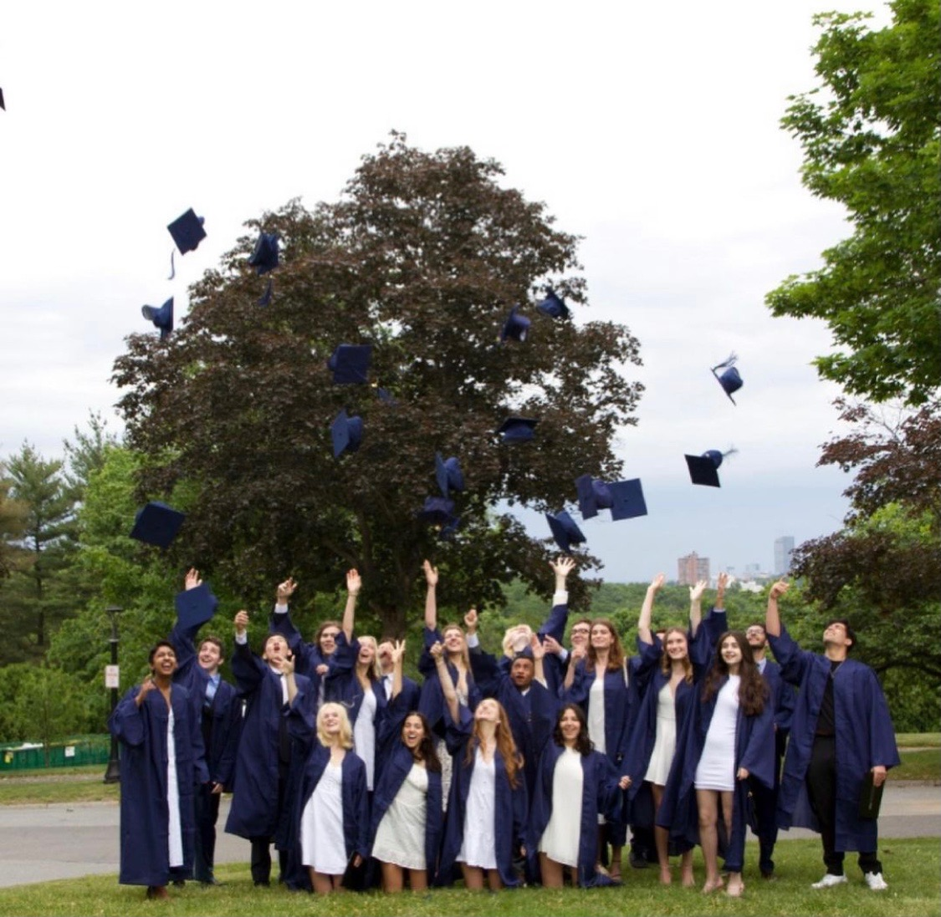

Finally, the Head of School Darren Nicholas then gave a silent speech and a whimsical performance of the graduating class’ top songs.

A standing ovation from the entire tent concluded the event as the graduates flipped their tassel over onto the other side of their cap, signifying the earning of their high school diploma.

Congratulations Class of 2021!